**Please could you check and edit following Errors in Ars Vivendi Magazine <http://www.apex-portal.com/arsvivendi/magazine/index.php>**

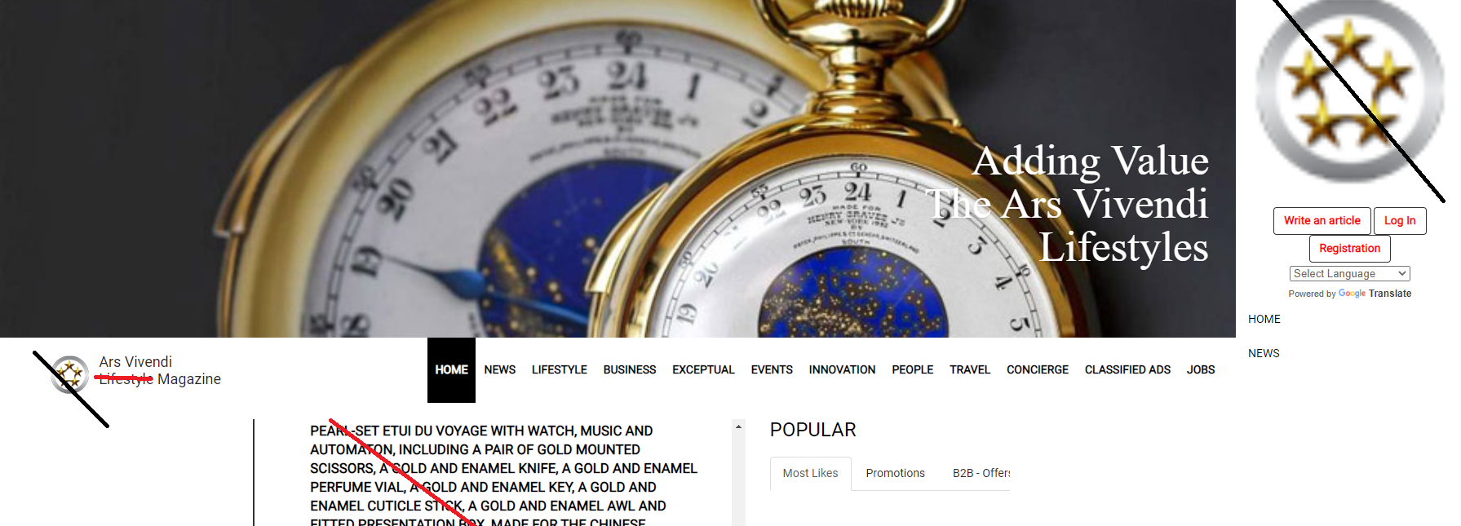

* Logo not correct please us Ars Vivendi logo
* Article not correct
* PHP Programming missing
* Wordpress programming not correct
* Footer row needs update

<http://www.apex-portal.com/arsvivendi/magazine/index.php>

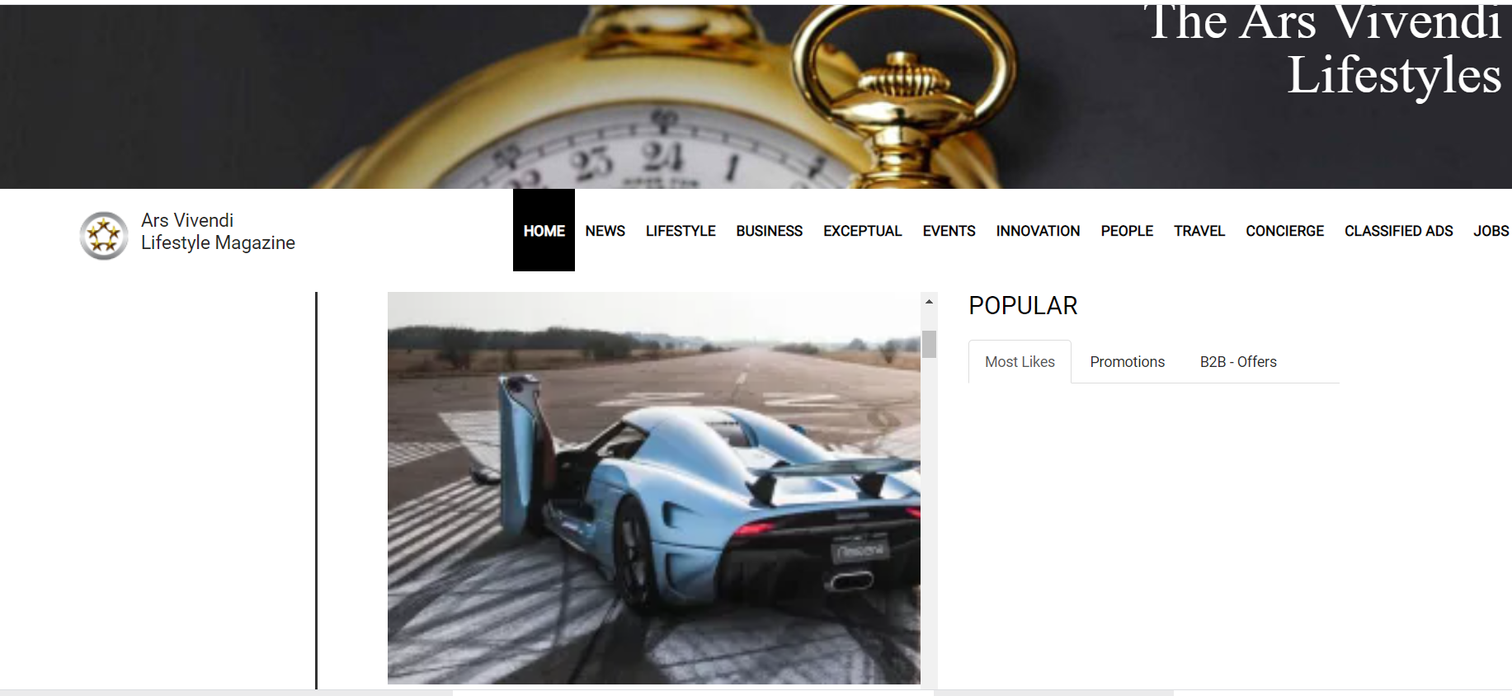

Please check uploaded article ..

show only one picture and text per article,

if click show link to my site -activities of member

test article with car was made in Ars Vivendi Magazine

please not show all articles of all other magazines in all magazines

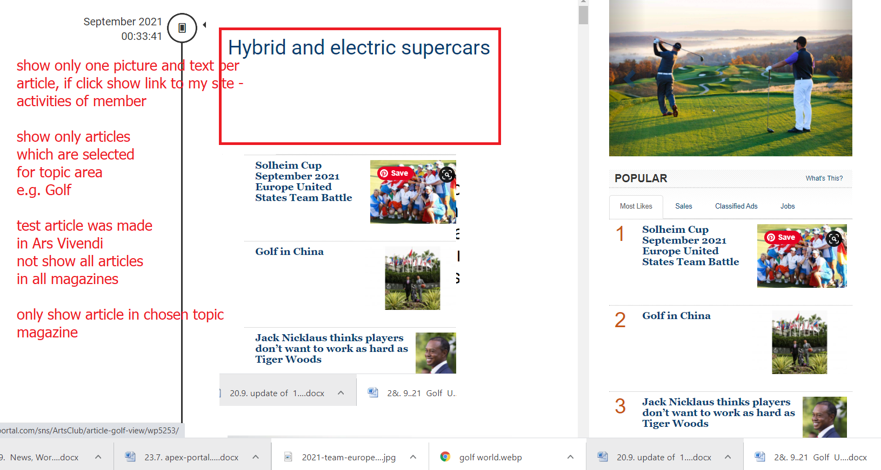

e.g. hybrid car = article was uploaded to ars vivendi magazine

Now shown in Golf

please check and not allow other topic areas articles to show, only allow the chosen one to show

Thank you for check and let us know

about your evaluation of above errors to fix

Best regards